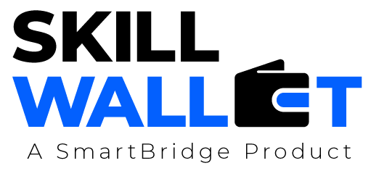

Communication

Date | 13 july 2026
Team ID | SWTID-2026-2203
Project Name | Smart lender
Maximum Marks | 1 Mark

Communication Plan:
Effective communication is essential for a successful project demonstration. This document outlines the communication strategy used within the team and with stakeholders throughout the project lifecycle, including how updates, issues, and feedback were managed.

S.No | Communication Type | Frequency | Channel / Tool | Participants | Purpose
1 | Team Standup | Daily | zoom | Dev team,PO | Track daily progress and blockers.
2 | Progress Update | Weekly | email | stakeholder | Share project status and milestones.
3 | Issue / Bug Discussion | As Needed | slack | Devs,QA | Resolve technical debt and bugs.
4 | Stakeholder Review | Bi-Weekly | MS teams | Client,PM | Demo features and gather feedback.
5 | Final Demo Rehearsal | Once | Video conf | Core team | Ensure a smooth final presentation
6

Communication Challenges & Resolutions:
S.No | Challenge Faced | Resolution / Action Taken
1 | Data Privacy Concerns: Delays in accessing sensitive financial datasets for model training. | Implemented data anonymization and used synthetic data for initial development stages.
2 | Technical Silos: Misalignment between the Frontend team and the ML team regarding API integration. | Held dedicated "Sync-up" sessions and created comprehensive Swagger documentation.
3 | Time Zone Gaps: Communication delays between distributed team members. | Established "Golden Hours" (overlapping 2-hour windows) for live collaboration and used Jira for async updates.

